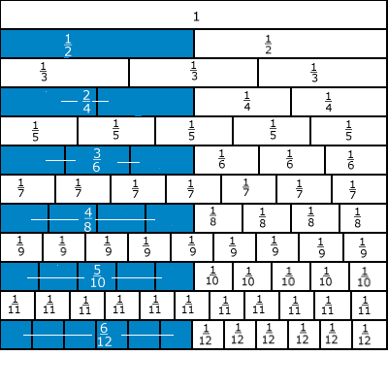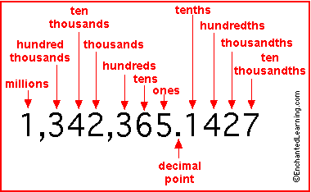

We are learning about Fractions, Decimals and
Percentages

Lynda Keith
University of Strathclyde
©2006
I am learning:
A fraction is part of a whole.

The value of a common fraction lies between 0 and 1.

To find half of a number you divide by 2.

If a shape is divided into 10 equal parts, each is called one tenth.

You can identify tenths by colouring and folding.

One tenth can be written as $\frac{1}{\text{10}}$
The numerator is the top digit in a fraction and it represents the number of fractional parts.

The denominator is the bottom digit in a fraction and it represents the number of fractional parts the unit has been divided into.

10 tenths is the same as one whole.

To find a tenth of a number you divide by 10.

I am learning:
To find a quarter of a number you divide by 4.

To find a third of a number you divide by 3.

To find a fifth of a number you divide by 5.

To find a sixth of a number you divide by 6.

To find an eighth of a number you divide by 8.

To find ⅜ of 24
- divide by the denominator
then
- multiply by the numerator.
I am learning:

Decimal fractions are an extension of our place value system.

A decimal fraction is a fractional number expressed using places to the right of the decimal point.

The decimal point separates digits with a value greater than one from those with a value less than one.

The decimal point does not move in addition and subtraction calculations.

The position of the decimal point changes in multiplication and division calculations.

When rounding to the nearest whole number, look at the first digit which comes just after the decimal point.

I am learning:

A percentage is a fraction with a denominator of 100.

When a shape is divided into 100 ‘ bits ’ each bit is called 1 percent.

We can use the symbol % for percent.

We can change any fraction into a decimal then into a percentage.

Some percentages are used frequently: 50% = ½

I am learning:

Equivalent fractions are important for comparison.

Equivalent fractions have the same value but are expressed differently.

Because they have the same value they appear on the number line in the same place.

To make an equal fraction, multiply the top and bottom number by the same number.

To make an equal fraction, divide the top and bottom by the same number.

We can simplify a fraction by dividing the top and bottom by the same numbers.

To multiply by 100 move each digit two places to the right.

To divide by 100, move each digit two places to the left.

I am learning:

An improper fraction is a fraction which has a numerator which is larger than the denominator.

A mixed number is a number with a mix of whole number and fractional parts.

10 hundredths is the same as 1 tenth.

